Lab Session 7 (Project)

Project

Blooms Taxonomy | GAs | Marks
(P3) | GA-5 | 5
(A3) | GA-3 | 10
NAME | STUDENT ID
HASSAN ALI | 71280
RUKHSAR FATIMA | 68481
SHAIQUE ANSARI | 68430
ABDULLAH ABRAR | 71499

Title: Clinic Management System
Objective:
The objective of this project is to design and implement a simplified Clinic Management System (CMS) using MIPS Assembly Language. The system aims to demonstrate how basic healthcare operations such as patient registration, disease assignment, billing, and record management can be performed on low-resource, RISC-based architectures, emphasizing low-level programming concepts like memory management, syscalls, and control flow.
Motivation:
This project is motivated by the need to understand how real-world applications can be built in resource-constrained environments, such as embedded medical systems. By using MIPS Assembly instead of high-level languages, students gain hands-on experience in direct hardware interaction, static memory handling, and syscall-based I/O, which strengthens their understanding of computer organization and embedded system principles.
Problem Statement:
In many developing regions and embedded medical environments, healthcare data management systems must operate on hardware with minimal operating system support. While most modern clinical systems are implemented using high-level languages, there is strong educational value in exploring how such systems can be modeled using MIPS Assembly Language.
The challenge is to implement a basic yet functional clinic management system capable of handling patient data efficiently under strict architectural constraints.
Design / Ways & Means:
Introduction and Requirements
• Use of MIPS Assembly Language • Execution on MARS / QtSPIM simulator • Static memory allocation only • Menu-driven interface using syscalls • Support for up to 10 patients (ID 0–9)
Basic Implementation
• Parallel arrays used for patient data (names, gender, contact, disease, date, billing • Syscalls used for input/output operations • Labels and branch instructions used for modular program flow • Fixed doctor assignment and predefined disease list

Performance Testing and Analysis
• Tested using multiple patient IDs • Verified correct memory indexing and data retrieval • Checked billing calculations and risk-level logic • Observed fast execution due to minimal instruction overhead
Optimization and Advanced Features
• Efficient offset-based addressing (ID × field size) • Minimal syscall usage to reduce overhead • Reuse of registers to limit instruction count
Extensions and Creativity
- Risk assessment system (Green, Yellow, Red)
- Suggested medicine based on disease code
- Add and delete patient record functionality
- Modular menu-based interaction

Deliverables:
Background/Theory
The project is based on MIPS RISC architecture, which uses simple instructions and a fixed syscall interface. It demonstrates concepts such as:
- Static memory management using . space
- Parallel array data structures
- Label-based procedural programming
- Syscall-driven input/output
These concepts are commonly applied in embedded systems and firmware design.
Procedure / Methodology
• Analyze system requirements and constraints • Design memory layout using static buffers • Implement menu-driven control flow • Develop individual features (register, billing, view, delete) • Test each module in MARS simulator • Debug and validate outputs

Data Collection (If required)
No external data collection was required.
All patient data is entered dynamically by the user at runtime via syscall-based input and stored temporarily in memory.
Flowchart / Block diagram
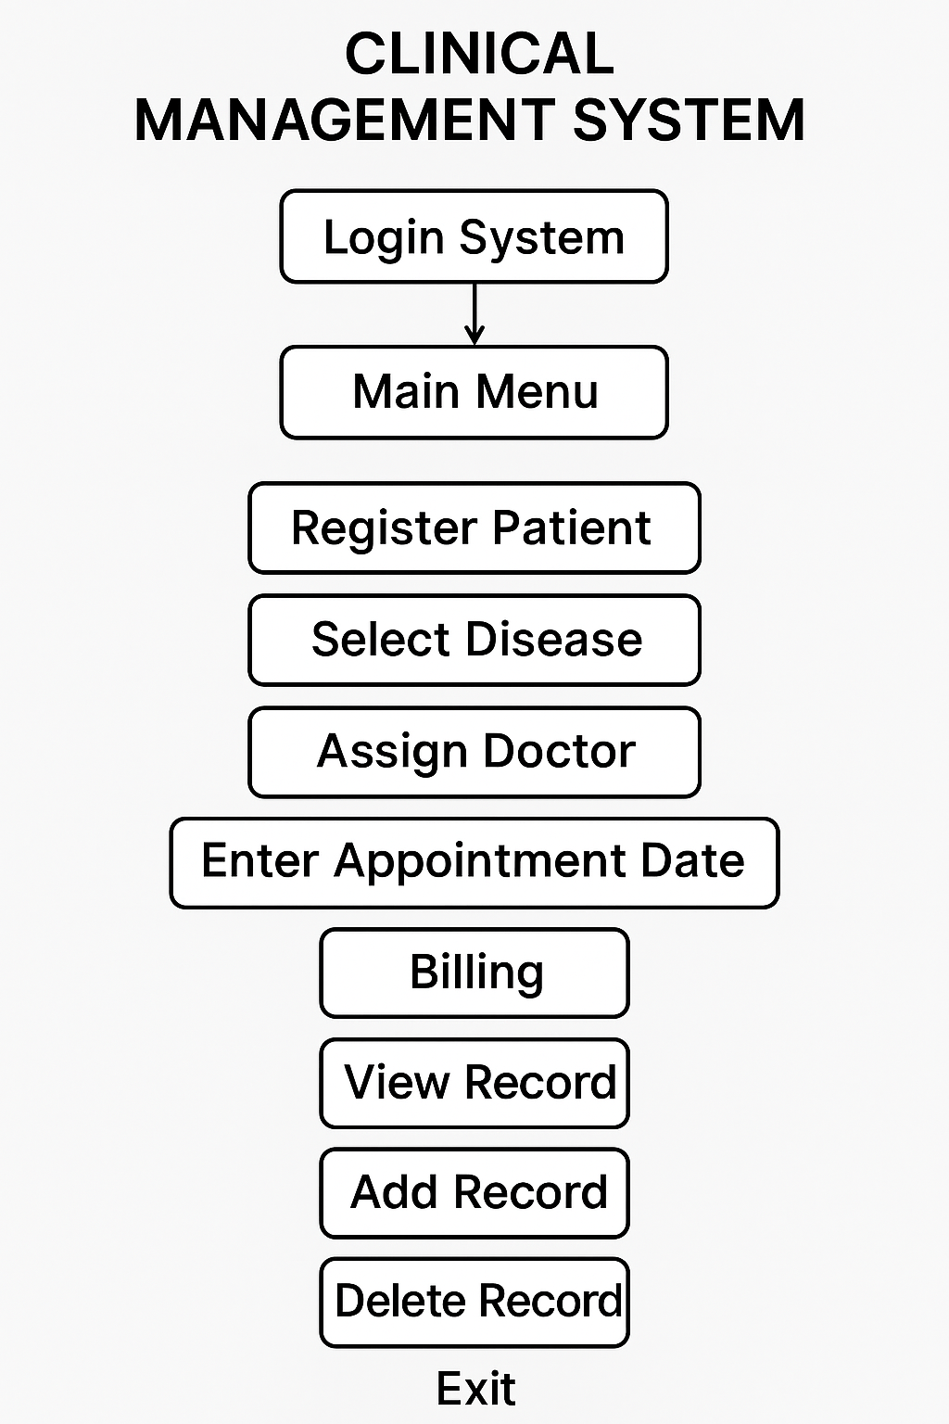

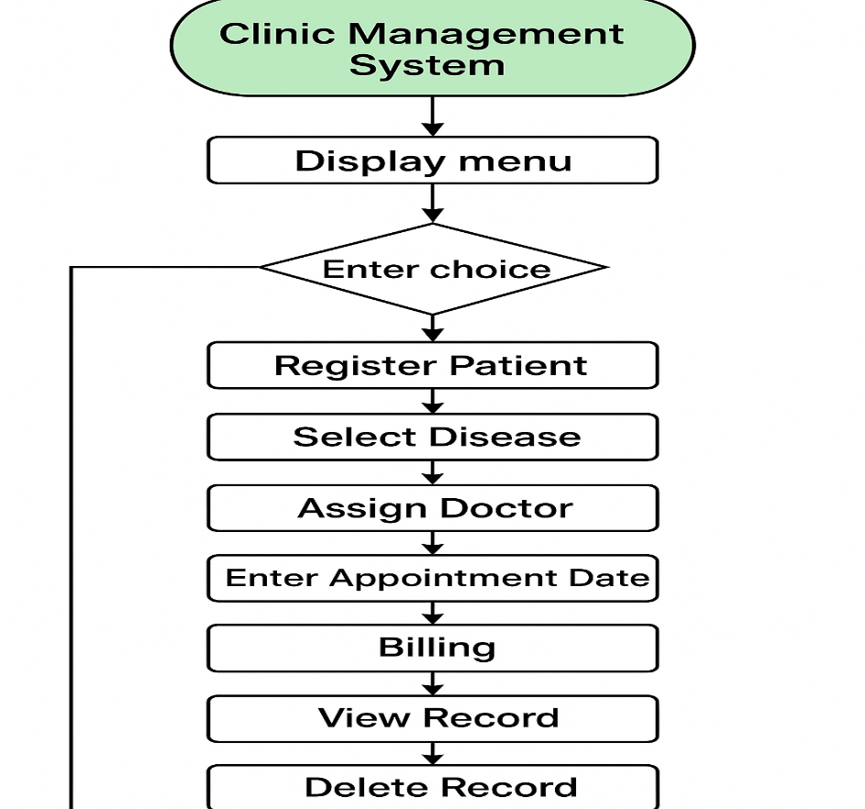

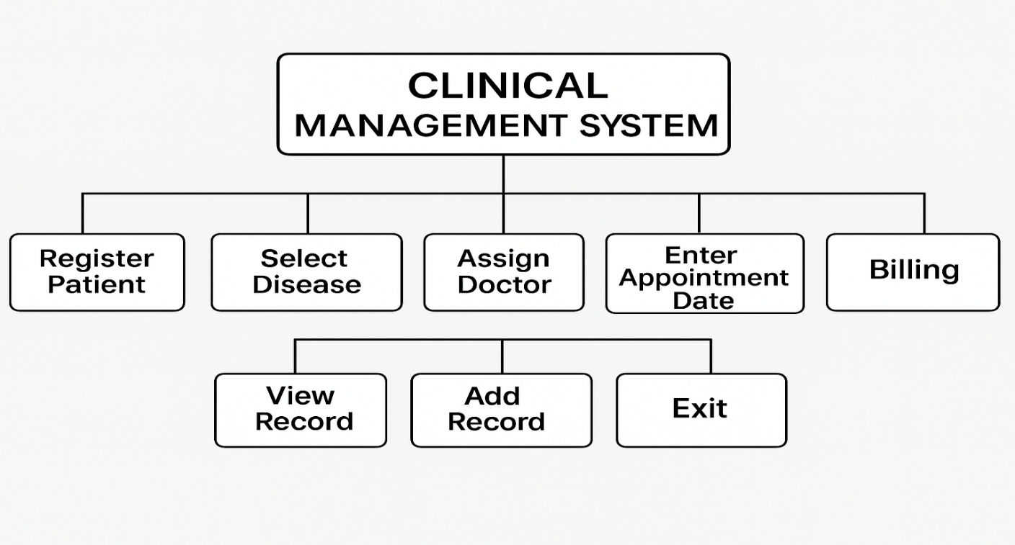

Analysis
• The system efficiently handles clinic operations within static memory limits • Parallel arrays simplify structured data handling • Control flow using branches ensures modularity • Limitations include lack of persistent storage and input validation
Results
• Patient registration stored correct data • Billing computed using 500 + (disease code × 100) accurately • Risk level and medicine suggestions displayed correctly • Add/Delete functions worked as expected • Program terminated successfully using syscall 10
Discussion on Results
The system demonstrates that low-level assembly programming can effectively simulate real-world applications under constraints. However, extending features such as persistent storage, sorting, or advanced validation would be complex in pure assembly. This highlights why high-level languages are preferred for production systems, while assembly remains valuable for learning and embedded applications.
Concluding Remarks
The Clinic Management System successfully illustrates how healthcare-related functionalities can be implemented in a low-resource environment using MIPS Assembly. The project strengthened understanding of memory management, syscall usage, and control flow without high-level abstractions. Despite its limitations, the system serves as a strong educational model for embedded systems and computer architecture students.
Reference
• IEEE (2019). Lightweight EHR Systems for Rural Health Centers • ACM SIGCSE (2016). Teaching Computer Organization with MIPS Assembly Projects • Elsevier (2017). Embedded Patient Monitoring Systems

SOURCE CODE
.data
menu: .asciiz "\n\n1. Register Patient\n2. Select Disease\n3. Assign Doctor\n4. Enter Appointment Date\n5. Billing\n6. View Record\n7. Add Record\n8. Delete Record\n9. Exit\nEnter your choice: "

enter_id: .asciiz "Enter patient ID (0-5): "
name_prompt: .asciiz "Enter patient name: "
gender_prompt: .asciiz "Enter gender (M/F): "
contact_prompt: .asciiz "Enter contact number: "
disease_menu: .asciiz "\n1. Fever\n2. Cold/Cough\n3. Headache\n4. Allergy\n5. Flu\n6. Vomiting\n7. Stomach flu\n8. Sore throat\nChoose disease: "
doctor_assigned: .asciiz "Doctor assigned: Dr. Zain\n"
date_prompt: .asciiz "Enter appointment date (DDMM): "
bill_prompt: .asciiz "Total Bill: "
view_prompt: .asciiz "Enter patient ID to view: "
green_text: .asciiz "\nRisk Level: LOW (Green)"
yellow_text: .asciiz "\nRisk Level: MEDIUM (Yellow)"
red_text: .asciiz "\nRisk Level: HIGH (Red)"
med_prompt: .asciiz "\nSuggested Medicine: "
newline: .asciiz "\n"
add_msg: .asciiz "Enter Patient ID (6-9): "
name_msg: .asciiz "Enter Patient Name: "
search_id_msg: .asciiz "Enter Patient ID to delete: "
deleted_msg: .asciiz "Record deleted.\n"
not_found_msg: .asciiz "Record not found.\n"

medicine_table:
.asciiz "Paracetamol "
.asciiz "Benadryl "
.asciiz "Panadol Extra "
.asciiz "Cetirizine "
.asciiz "Tamiflu "
.asciiz "Ondansetron "
.asciiz "ORS & Flagyl "
.asciiz "Strepsils "

names: .space 200
genders: .space 10
contacts: .space 100
diseases: .space 10
dates: .space 100
bills: .space 40

.text
.globl main

main:
menu_loop:
li $v0, 4
la $a0, menu
syscall

li $v0, 5
syscall
move $t0, $v0

beq $t0, 1, register
beq $t0, 2, select_disease
beq $t0, 3, assign_doctor
beq $t0, 4, enter_date
beq $t0, 5, billing
beq $t0, 6, view_record
beq $t0, 7, add_record
beq $t0, 8, delete_record
beq $t0, 9, exit

j menu_loop

register:
li $v0, 4
la $a0, enter_id
syscall
li $v0, 5
syscall
move $t1, $v0

li $v0, 4
la $a0, name_prompt
syscall
li $v0, 8
la $t2, names
mul $t3, $t1, 20
add $a0, $t2, $t3
li $a1, 20
syscall

li $v0, 4
la $a0, gender_prompt
syscall
li $v0, 12
syscall
move $t4, $v0
la $t5, genders
add $t5, $t5, $t1
sb $t4, 0($t5)

li $v0, 4
la $a0, contact_prompt
syscall
li $v0, 8
la $t2, contacts
mul $t3, $t1, 10
add $a0, $t2, $t3
li $a1, 10
syscall

j menu_loop

select_disease:
li $v0, 4
la $a0, enter_id
syscall
li $v0, 5
syscall
move $t1, $v0

li $v0, 4
la $a0, disease_menu
syscall
li $v0, 5
syscall
move $t2, $v0

la $t3, diseases
add $t3, $t3, $t1
sb $t2, 0($t3)
j menu_loop

assign_doctor:
li $v0, 4
la $a0, enter_id
syscall
li $v0, 5
syscall

li $v0, 4
la $a0, doctor_assigned
syscall
j menu_loop

enter_date:
li $v0, 4
la $a0, enter_id
syscall
li $v0, 5
syscall
move $t1, $v0

li $v0, 4
la $a0, date_prompt
syscall
li $v0, 5
syscall
move $t2, $v0

la $t3, dates
add $t3, $t3, $t1
sb $t2, 0($t3)
j menu_loop

billing:
li $v0, 4
la $a0, enter_id
syscall
li $v0, 5
syscall
move $t1, $v0

la $t2, diseases
add $t2, $t2, $t1
lb $t3, 0($t2)

li $t4, 500
li $t5, 100
mul $t6, $t3, $t5
add $t7, $t6, $t4

la $t8, bills
add $t8, $t8, $t1
sb $t7, 0($t8)

li $v0, 4
la $a0, bill_prompt
syscall
li $v0, 1
move $a0, $t7
syscall
j menu_loop

view_record:
li $v0, 4
la $a0, view_prompt
syscall
li $v0, 5
syscall
move $t1, $v0

la $t2, names
mul $t3, $t1, 20
add $a0, $t2, $t3
li $v0, 4
syscall

li $v0, 4
la $a0, newline
syscall

la $t2, genders
add $t2, $t2, $t1
lb $a0, 0($t2)
li $v0, 11
syscall

li $v0, 4
la $a0, newline
syscall

la $t2, contacts
mul $t3, $t1, 10
add $a0, $t2, $t3
li $v0, 4
syscall

li $v0, 4
la $a0, newline
syscall

la $t2, bills
add $t2, $t2, $t1
lb $a0, 0($t2)
li $v0, 1
syscall

li $v0, 4
la $a0, newline
syscall

la $t2, diseases
add $t2, $t2, $t1
lb $t5, 0($t2)

li $v0, 34
ble $t5, 2, green_risk
ble $t5, 5, yellow_risk
j red_risk

green_risk:
li $v0, 4
la $a0, green_text
syscall
j suggest_meds
yellow_risk:
li $v0, 4
la $a0, yellow_text
syscall
j suggest_meds
red_risk:
li $v0, 4
la $a0, red_text
syscall
suggest_meds:
li $v0, 4
la $a0, med_prompt
syscall

la $t6, medicine_table
addi $t5, $t5, -1
mul $t5, $t5, 20
add $a0, $t6, $t5
li $v0, 4
syscall

j menu_loop

add_record:
li $v0, 4
la $a0, add_msg
syscall
li $v0, 5
syscall
move $t1, $v0

blt $t1, 0, add_exit
bgt $t1, 9, add_exit

li $v0, 4
la $a0, name_msg
syscall
li $v0, 8
la $t2, names
mul $t3, $t1, 20
add $a0, $t2, $t3
li $a1, 20
syscall

add_exit:
j menu_loop

delete_record:
li $v0, 4
la $a0, search_id_msg
syscall
li $v0, 5
syscall
move $t1, $v0

li $t2, 0
li $t3, 0

li $t4, 20
mul $t5, $t1, $t4
la $t6, names
add $t6, $t6, $t5

li $t7, 0
clear_name_loop:
li $t8, 0
sb $t8, 0($t6)
addi $t6, $t6, 1
addi $t7, $t7, 1
blt $t7, $t4, clear_name_loop

li $v0, 4
la $a0, deleted_msg
syscall
j menu_loop

exit:
li $v0, 10
syscall
SOURCE CODE SCREEN SHOTS
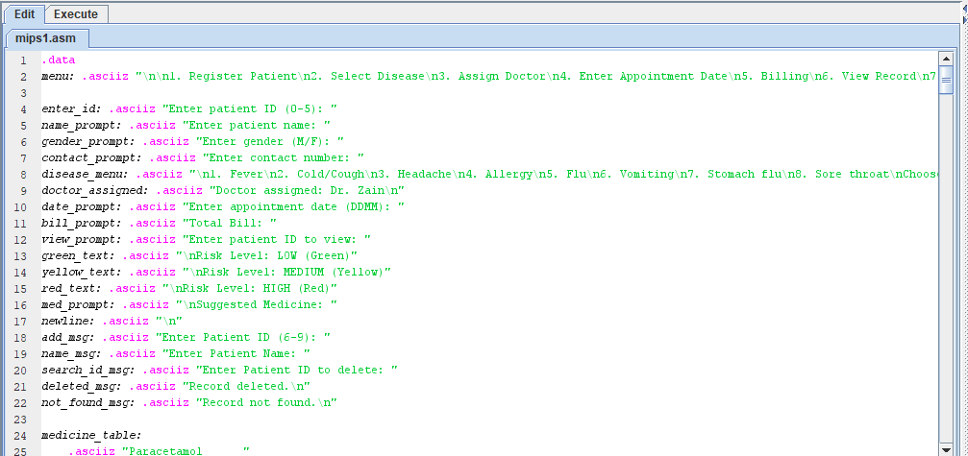
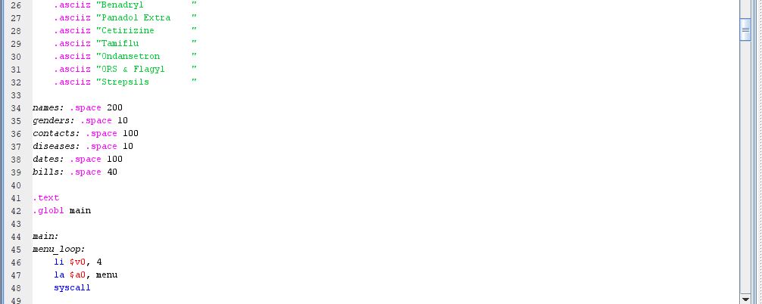
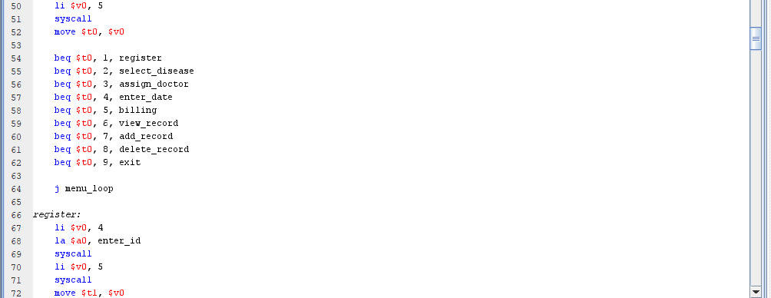
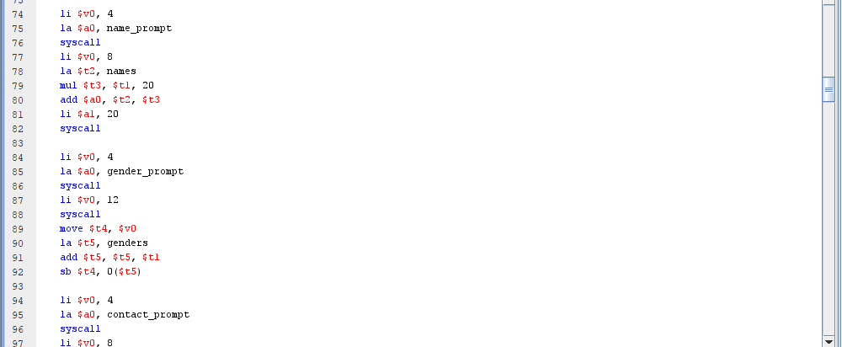
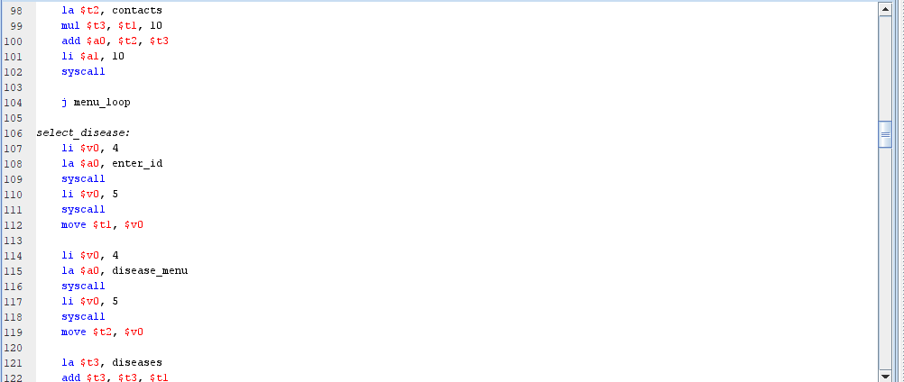

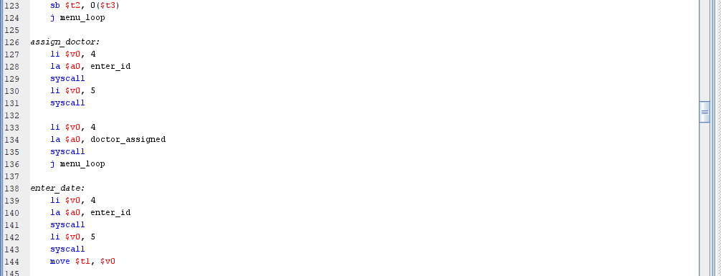
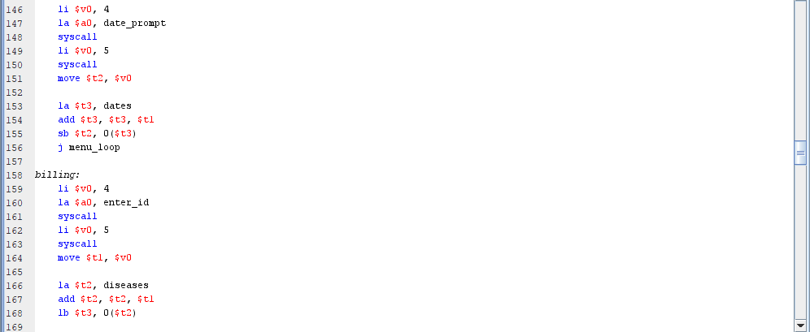
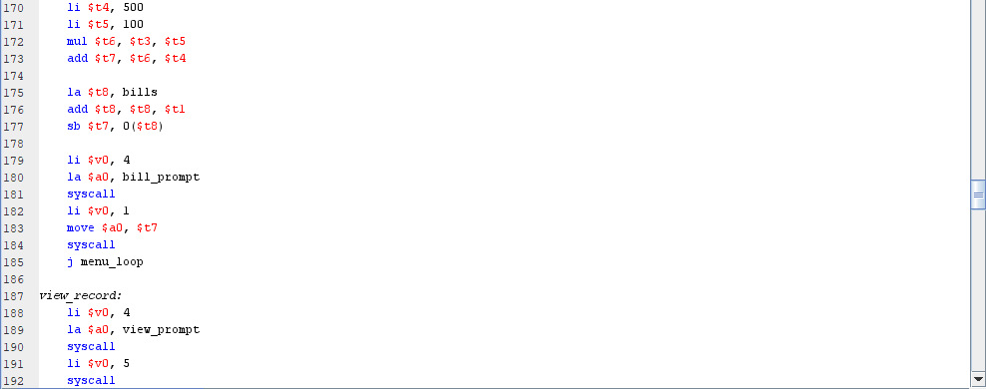

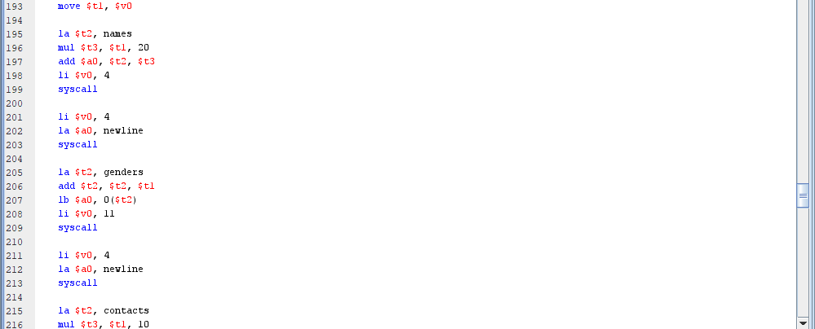

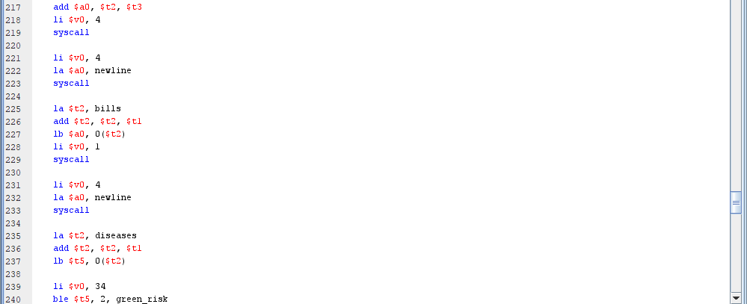
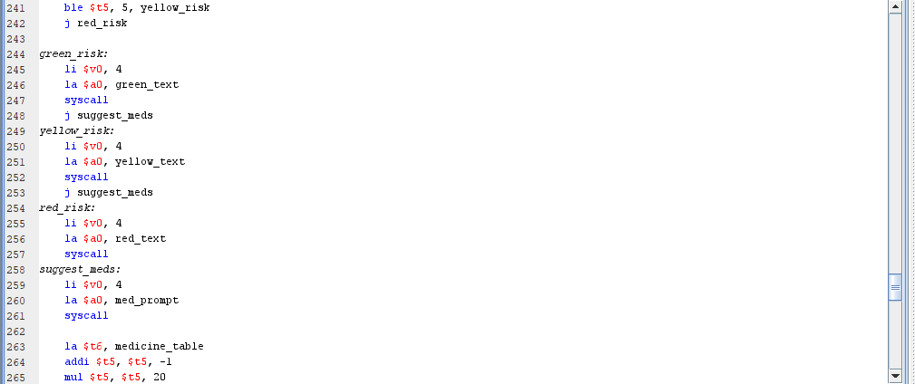
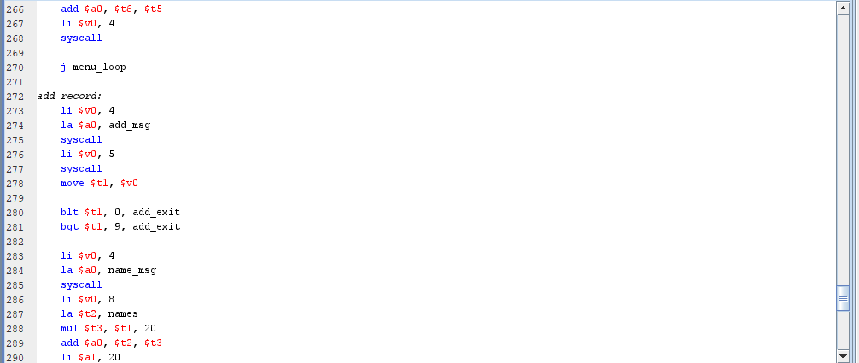
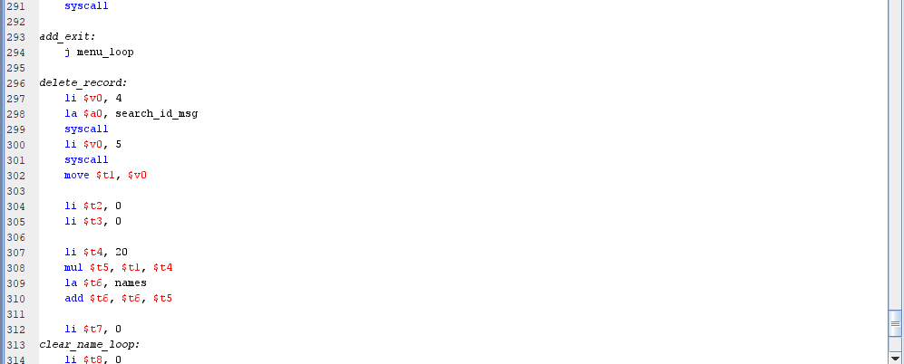
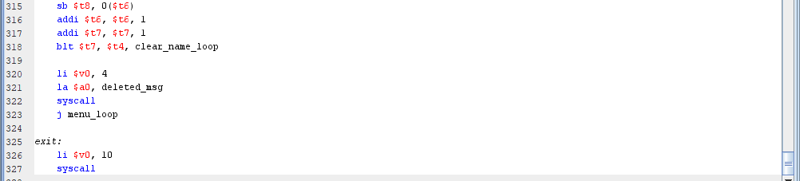

OUTPUT
MENU:
1. Register Patient
2. Select Disease
3. Assign Doctor
4. Enter Appointment Date
5. Billing
6. View Record
7. Add Record
8. Delete Record
9. Exit
1.Register Patient :
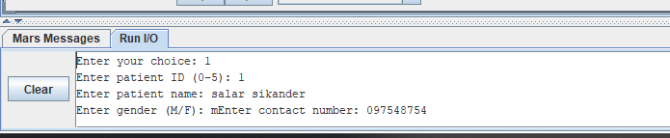

2. Select Disease
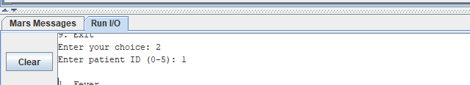
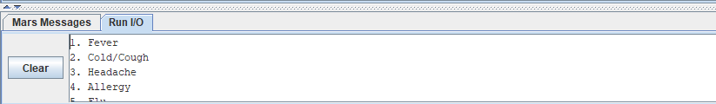
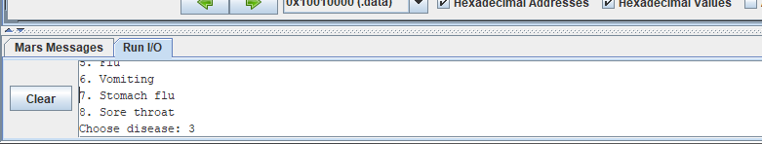
3.Assign Doctor:
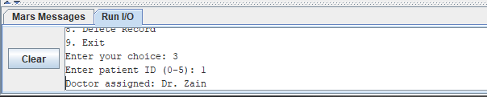
- Enter Appointment Date:
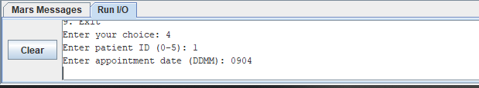

- Billing:
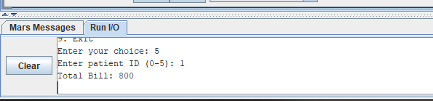
- View Record:
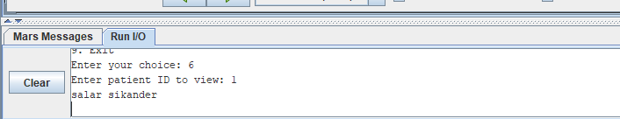
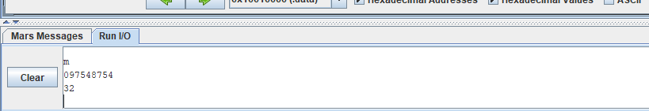
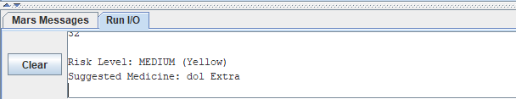
- Add Record
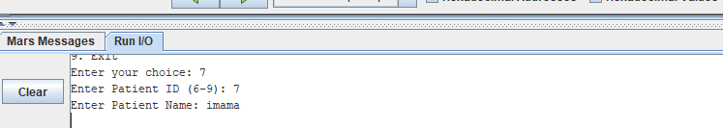

- Delete Record
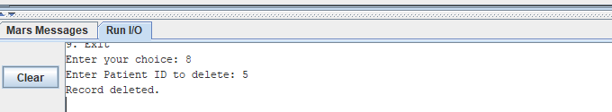
- Exit:
